Small Scale Interoperable Social Media: A Design

Framework For Decentralization

Akshay Vijay Nair   
Seidenberg School of CSIS *Pace University*New York, NY, USA

[akshay.v.nair@pace.edu](mailto:akshay.v.nair@pace.edu)  
<https://orcid.org/0009-0005-4190-4334>

*Abstract*—The pitfalls of using centralized social media platforms for individuals and institutions have been well documents and analyzed. Those pitfalls led to the rise of decentralized social media platform. Initially, the technical challenges surrounding the developments and maintenance were high. That however has changed significantly with open-source solutions, widely accepted open protocols and the lowering cost of cloud services for infrastructure. This paper explores the design for a social media system for internal institutions and organizations.

Keywords—social media, decentralization, system design

# Introduction

There have been in the past many hurdles to creating new social media software. At every stage of the SDLC, these platforms have been challenging from and engineering and cost perspective. There has recently been a convergence of new technologies, and new documentation, that are now capable of addressing these problems.

Open discussions on social media’s role and use-cases provided a framework to simplify requirement gathering process for a new system [1].

From a design standpoint, open protocols were established. Taking inspiration from how email systems work, work was done on creating a consensus towards a common protocol for social media networks that would allow for decentralization. In 2018, W3C made ActivityPub the standard recommendation [2]. This greatly simplified system design for platforms in the future.

From an engineering and deployment perspective, another traditional hurdle to building such systems had been the general cost and engineering complexity for the servers that were needed to be built for a reliable system. Cloud service providers greatly ease the on both of these fronts.

The last hurdle to these systems were on the operation and maintenance front. The rise of LLMs such as GPT-4 and Llama have reduced the complexity of moderation [3]. Integration of these services into platforms removes the last of the hurdles towards small scale social media that would serve internal communities or organizations.

# Motivation and Background

## Motivation

Centralized social media as part of Web 2.0 was envisioned as a way to digitize social interaction among individuals and groups. While it did originally show promise, there were unintended consequences. Some of the well-known downsides are user tracking, negative mental health impact on individuals, and proliferation of extreme content.

More than 90% of users on these platforms are passive consumers [4]. Since these platforms serve content to user algorithmically, they have turned into content consumption systems rather than meaningful social engagements. Combating misinformation and managing bad actors in these spaces have been a ever growing problem [5]

A large part of the consequences stem with the large user bases of these platforms. There are platforms with billions of users. User data monetization of a free service led to widespread tracking and privacy concerns. Social media platforms with billions of users essentially turned the business model of a digital townhouse to advertising engines of the current internet.

These problems have been highlighted many times and platforms have taken steps to rectify them. However, they have largely been ineffective or controversial [6]. To solve the many problems of large centrally governed platforms, decentralized social media platforms led the charge these were initially bogged down by platforms attempting to leverage blockchain technology [7]. There was however, a middle ground between the two that have shown promise.

Services like Mastodon have shown that removing the blockchain aspect of decentralization and focusing on creating smaller more engaged communities have shown meaningful results [8].

## Background

Outside of providing for niche communities, this new approach offers other opportunities. Since a lot of the technology is open-sourced. It is possible for services to crop up that are wholly internal with limited access to the Fediverse. This new paradigm offers a way to digitize internal communications within institutions. With the ability to own your data, technology, and moderate as per the wishes of the participants, the fine control can be beneficial to organizations as an internal social media network. This walled spaces for communities also allows for users to express more freely.

The design of these systems can be varied but largely should follow some variation of the same core building blocks:

* Client Interface
* Server(s) which can serve instance users (internal)
* Server(s) that can interface with the wider Fediverse
* Content filters and moderation controls for incoming and outgoing content
* Database(s)

# High Level Architechture

If we begin from the ActivityPub protocol, it establishes 2 broad layers: a server-to-server federation protocol, and a client to server protocol. These are often translated into 2 separate endpoints, i.e a social API and a federation API

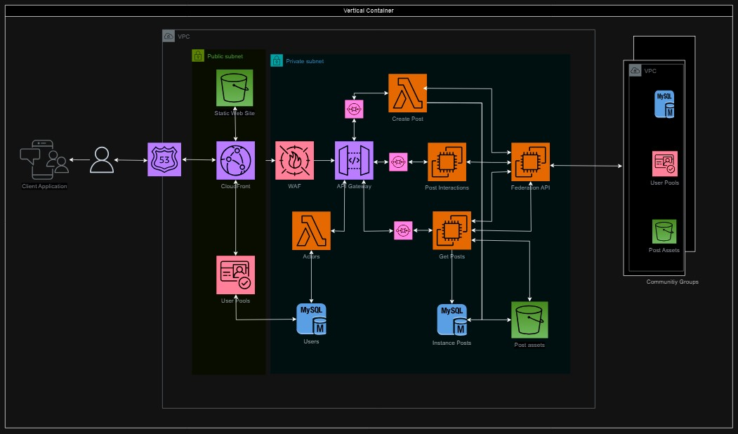

Fig. 2. Simplified AWS design for ActivityPub compliant system

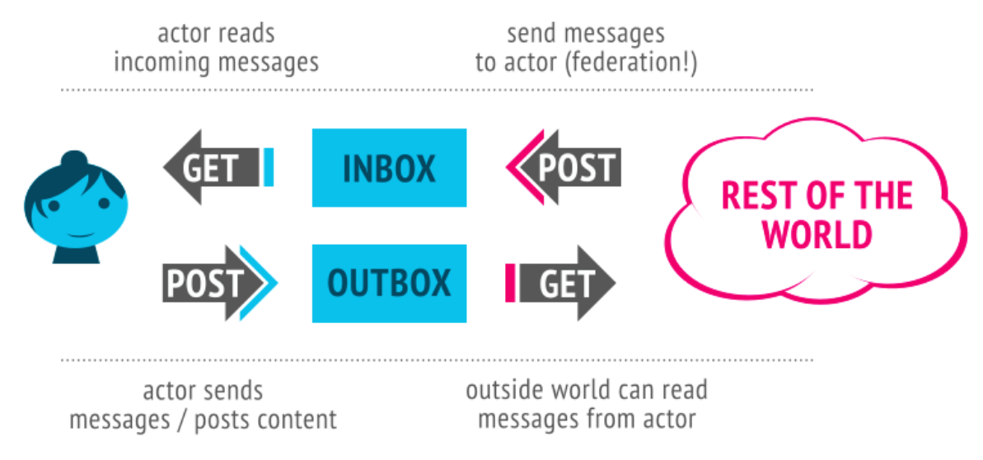

1. General user flow for ActivityPub services

## Client Side Interface

Client interfaces are available as a open source solutions on different digital mediums. Clients must have 2 core capabilities

* They must be compliant with ActivityPub Social API requirements.
* They should be able to support OAuth2.0 authorization mechanisms. Authorization could be provided by the institutions.

Clients can be highly customized in terms of UI, features and content. ActivityPub supports a variety of post types that would cater to anything between microblogging to image and video sharing [10]. This allows for clients to exist independently of the communities that it accesses.

## Client to internal service

The first destination of all posts should be the local instance domain of the user.

* These servers must transmit all posts on the server to instance users to consume.
* They must also be capable of offering authentication to users wishing to access the instance.
* This is the first level of user generated content; the content and moderation rules of the instance is governed by instance owners.
* Instance owners can govern posts that are being received to it from external servers and has authority to manage the posts

## Server to other servers

The second part of this system would involve the instance’s capability to interface with other servers that are ActivityPub compliant. This is second level of user generated content.

Here instances can apply other set of filters that are stricter. Currently in practice instance owners on existing platforms like Mastodon exercise control via blacklists to servers that are inappropriate from them.

## An AWS based distributed system

Fig 2. Speaks to a simplified system that is a bare minimum requirement for internal groups

* The first part of this design involves the web application client. We’re hosting a react web-app and all relevant assets on an S3 bucket, which is pulled from AWS CloudFront when accessed.
* Additionally, all accesses are validated via AWS Cognito for user session management.
* When the user makes any interaction on the platform, it’ll trigger either a Lambda operation or hit an EC2 instance. The rationale behind these 2 services is simple: Social media applications have heavy read-write skews. To manage costs, all write operations will be hosted on a lambda service and the read operations on EC2 instances.
* All data is being stored on a Relational Database, since we don’t expect to scale down the database to 0 at any point, we’re going to use Aurora RDS as a database solution.

## Other design options

* Alternative approaches revolve around using established architectures. Figure 3 shows a monolithic based approach used by Mastodon where all the software for this system is bundled into one module [11].
* Figure 4 explores the possibility of using a micro-service approach but with a Command Query Response based design [12].

# Scaling the system for Moderation and Administration

Once a base system is built, modules can be added for moderations and administration, depending on the type of service, number of users on the platform.

## Manual Intervention by users and moderators

* ActivityPub already supports manually interacting with posts in many ways. These intervention methods are documented as part of Table 1.

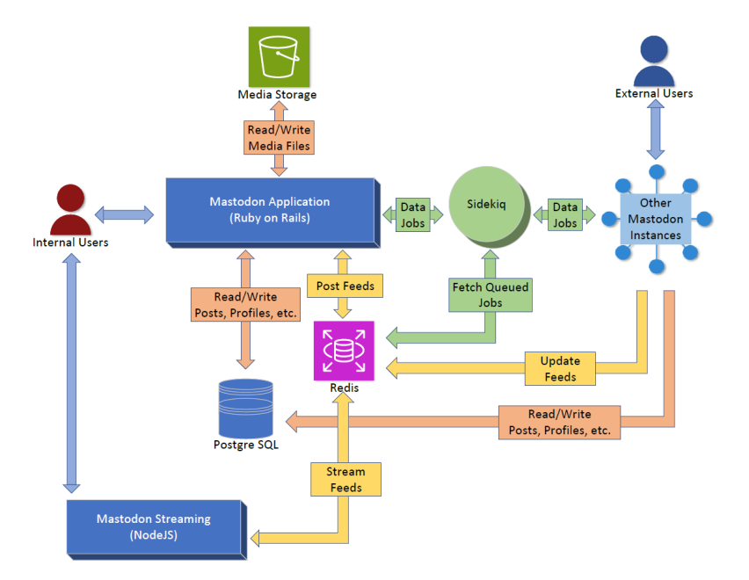

Fig. 3. Mastodon architechture

* Moderators also have the option of filtering out inappropriate external and internal instances entire via use of blacklisting.

| Type |
| --- |
|  | Description | Example |
| Flag | Indicates that the user is "flagging" the object. Flagging is defined in the sense common to many social platforms as reporting content as being inappropriate for any number of reasons. |  |
| Remove | Indicates that the actor is removing the object. If specified, the origin indicates the context from which the object is being removed. |  |

## Automated moderations tools

* With the use automated moderations tools based on Large Language Models like GPT-4 and Llamma, we can efficiently allow for moderators to be able to manage more on a single instance.
* There have been some studies done on the efficacy of the use of LLMs as content filters [3]
* With most approaches, filters can be applied at different levels depending on preference. An example

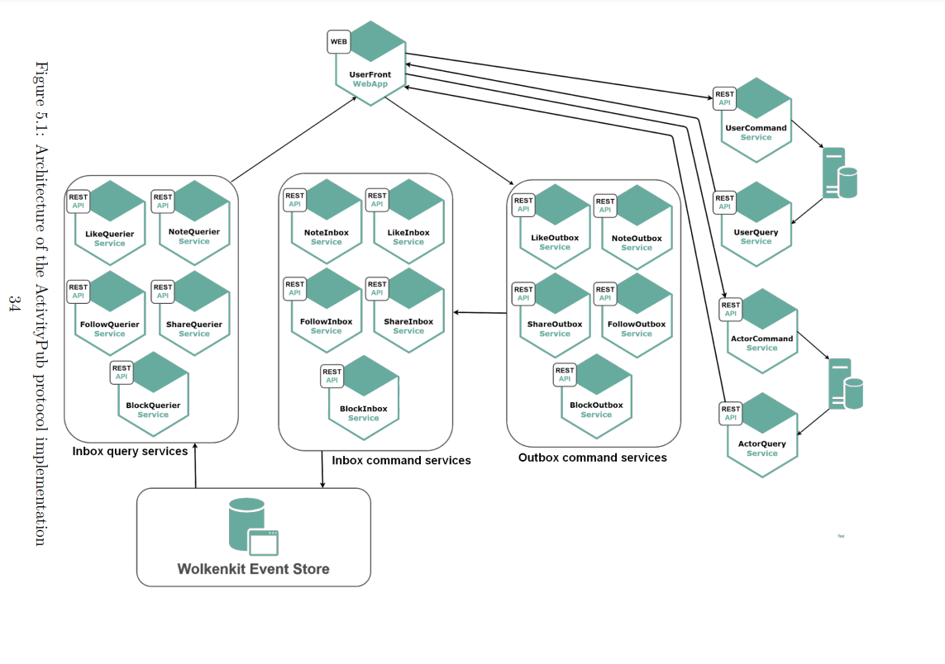

Fig. 4. CQRS based microservice approach

of how the filters can be integrated is shown as part of Fig. 5

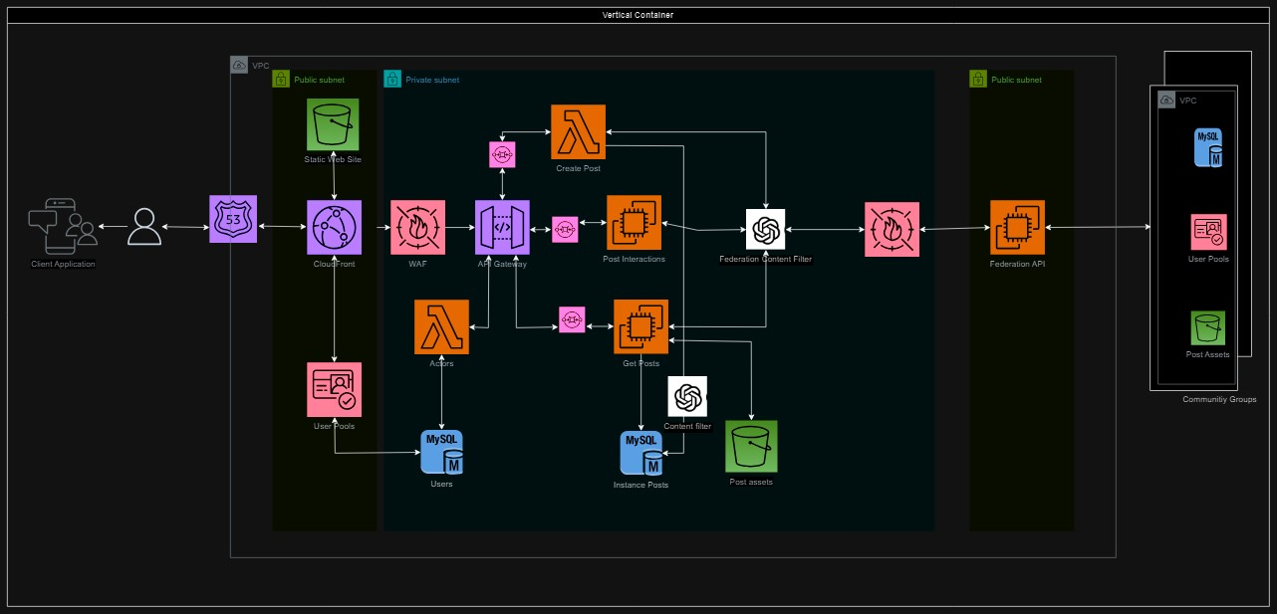

Fig. 5. ActivityPub system with LLM based content filters

## Creating internal communities

While ActivityPub focuses on a two-tiered approach, The same pattern can also be expanded into an N-tier system where different instances on an internal network can have different access rights.

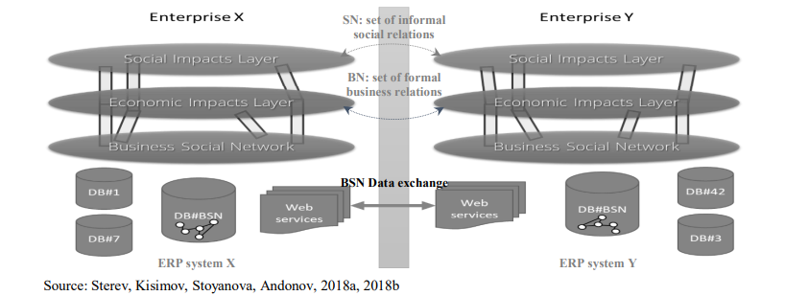

Fig. 5 N-Tier expansion of internal network communities

# Conclusions

Decentralization of social media networks has the potential to open new forms of digital social engagement. It has become clear that the digital town center idea of centralized platforms doesn’t work for many use cases. Decentralized Systems such as the ones described above have the ability to fill in the gaps and offering more niche options to the end user.

# Acknowledgment

Our thanks to Professor Sotirios Skevoulis for the opportunity to work on this concept and his guidance on how to research the topic.

# References

1. <https://www.w3.org/wiki/Socialwg>
2. <https://www.w3.org/TR/activitypub/>
3. Deepak Kumar, Yousef AbuHashem, and Zakir Durumeric “Watch Your Language: Investigating Content Moderation with Large Language Models” arXiv:2309.14517 [cs.HC] https://doi.org/10.48550/arXiv.2309.14517
4. K. Hemmings-Jarrett, J. Jarrett and M. B. Blake, "Evaluation of User Engagement on Social Media to Leverage Active and Passive Communication," 2017 IEEE International Conference on Cognitive Computing (ICCC), Honolulu, HI, USA, 2017, pp. 132-135, doi: 10.1109/IEEE.ICCC.2017.24.
5. J. Zhu, P. Ni and G. Wang, "Activity Minimization of Misinformation Influence in Online Social Networks," in IEEE Transactions on Computational Social Systems, vol. 7, no. 4, pp. 897-906, Aug. 2020, doi: 10.1109/TCSS.2020.2997188.
6. Greyson K. Young (2022) How much is too much: the difficulties of social media content moderation, Information & Communications Technology Law, 31:1, 1-16, DOI: 10.1080/13600834.2021.1905593
7. Yuanzhu Zhan, Yu Xiong, Xinjie Xing, A conceptual model and case study of blockchain-enabled social media platform, Technovation, Volume 119, 2023, 102610, ISSN 0166-4972, <https://doi.org/10.1016/j.technovation.2022.102610>
8. M. Zignani, C. Quadri, S. Gaito, H. Cherifi and G. P. Rossi, "The Footprints of a “Mastodon”: How a Decentralized Architecture Influences Online Social Relationships," IEEE INFOCOM 2019 - IEEE Conference on Computer Communications Workshops (INFOCOM WKSHPS), Paris, France, 2019, pp. 472-477, doi: 10.1109/INFCOMW.2019.8845221.
9. Andonov, Venko & Kisimov, Valentin & Stoyanova, Tsvetana & Sterev, Nikolay. (2020). DATA TRANSFER PROTOCOLS FOR BUSINESS SOCIAL NETWORKING. 37-44. 10.33965/is2020_202006L005.
10. [https://www.w3.org/TR/activitystreams-vocabulary/#extendedtypes](https://www.w3.org/TR/activitystreams-vocabulary/%23extendedtypes)
11. Empowering People with an Authoritative and Decentralized Social Media Platform, Mastodon white paper, https://doi.org/10.17613/ew6b-7s92
12. Lovisetto, Gary. A foundation for extensible and decentralized social networks.  Ecole polytechnique de Louvain, Université catholique de Louvain, 2019. Prom. : Riviere, Etienne. http://hdl.handle.net/2078.1/ thesis:19458